FAB Health Clinic, Netherlands

Paulette Agnew
Tooropstraat 43 Arnhem
Email: FABhealthclinic@gmail.com

Consultation form – Please complete in English

First Name: __________________________ Surname: _________________________
Full Address: ________________________________________________________________
Phone: ______________________________ Email: __________________________
Date of Birth: __________________________ Profession: __________________________

How did you find out about us? _________________________________________________

Which are your main complaints?
1. ___________________________________________________________________________
2. ___________________________________________________________________________
3. ___________________________________________________________________________

Which other therapists have you already seen regarding these complaints? (Please give also
address.)
Family doctor: ___________________________________________________________________
Other doctors / naturopaths / therapists: _____________________________________________
________________________________________________________________________________
________________________________________________________________________________
Which therapy method has given you relief?
_______________________________________________________________________________
_______________________________________________________________________________
_______________________________________________________________________________
Which therapy method was not helpful?
_______________________________________________________________________________
_______________________________________________________________________________
_______________________________________________________________________________
When and why have you received treatment in hospital / in a health clinic?
_______________________________________________________________________________
_______________________________________________________________________________
_______________________________________________________________________________

Did you have the following diseases or did you get vaccinated?

I had the I did not have Don’t Vaccinated
disease the disease know
Measles ____ ____ ____ ____
Mumps ____ ____ ____ ____
Rubella ____ ____ ____ ____
Whopping cough ____ ____ ____ ____
Smallpox ____ ____ ____ ____
Scarlatina ____ ____ ____ ____
Hepatitis A / B / C ____ ____ ____ ____
Yellow fever ____ ____ ____ ____
Diphtheria ____ ____ ____ ____
Poliomyelitis ____ ____ ____ ____
Chicken pox ____ ____ ____ ____
Typhoid fever ____ ____ ____ ____
CEE ____ ____ ____ ____
Malaria ____ ____ ____ ____
Other vaccinations, when?
_______________________________________________________________________________
_______________________________________________________________________________
_______________________________________________________________________________

Which diseases have occurred (several times) in your family? (Please give disease and family
member.)
_______________________________________________________________________________
_______________________________________________________________________________
_______________________________________________________________________________

Which operations have you undergone?
Year or No operation?
Tonsils _____________ __
Sinuses _____________ __
Ears _____________ __
Gall Bladder _____________ __
Appendix _____________ __
Stomach _____________ __
Kidneys _____________ __

Other Operations, for example lower abdomen, hernias, jaw surgery, extraction of wisdom tooth, organ
transplantation.
_______________________________________________________________________________
_______________________________________________________________________________

Accidents, fractures:
_______________________________________________________________________________
_______________________________________________________________________________
Severe illnesses / infections:
_______________________________________________________________________________
_______________________________________________________________________________
Addictions (medication, drugs, alcohol, nicotine):
_______________________________________________________________________________
_______________________________________________________________________________

Current medication (e. g. antibiotics, cardiac remedies, blood pressure remedies, cortisone, warfarin, etc.)
_______________________________________________________________________________
_______________________________________________________________________________

Skin diseases, hair loss, skin fungus, fungus of the genitals:
_______________________________________________________________________________
_______________________________________________________________________________

Overseas stays (e.g. India, Africa, South America):
_______________________________________________________________________________
_______________________________________________________________________________

Treatments for fungus, parasites, intestinal reconditioning:
_______________________________________________________________________________
_______________________________________________________________________________

Pregnancies, births, miscarriages, abortion, intake of the “pill”, coil
_______________________________________________________________________________
_______________________________________________________________________________

Allergies, intolerances, hay fever? Since when?
_______________________________________________________________________________
_______________________________________________________________________________

Dental procedures (root canal treatment, tooth extraction, amalgam removal, implants, etc.)
_______________________________________________________________________________
_______________________________________________________________________________
_______________________________________________________________________________

Neurological diseases (MS, problems with brain or nervous system, psychiatric diseases) – since
when?
_______________________________________________________________________________
_______________________________________________________________________________

Autonomic nervous system disorders:
(1 = never, 10 = a lot) 1 2 3 4 5 6 7 8 9 10
Increased temperature ____________________________________________________________
Sweating ____________________________________________________________
Night sweat ____________________________________________________________
Easily excitable ____________________________________________________________
Nervousness ____________________________________________________________
Easily fatigued ____________________________________________________________
Concentration problems ____________________________________________________________
Weakness of memory ____________________________________________________________
Dizziness ____________________________________________________________
Weather sensitivity ____________________________________________________________

Headaches: (Where [one-sided / on both sides], when, how often?)
_______________________________________________________________________________
_______________________________________________________________________________

Cardiovascular System
(1 = never, 10 = a lot) 1 2 3 4 5 6 7 8 9 10
High blood pressure ____________________________________________________________
Low blood pressure ____________________________________________________________
Poor circulation (where?) ________________________________________________________
Vein inflammations ____________________________________________________________
Varicose veins ____________________________________________________________
Heart valve defect ____________________________________________________________
Myocardial disease ____________________________________________________________
Heart attack(s) ____________________________________________________________
Arrhythmias ____________________________________________________________
Pain in the heart region __________________________________________________________

Hormonal disorders
(1 = never, 10 = a lot) 1 2 3 4 5 6 7 8 9 10
Thyroid ____________________________________________________________
Parathyroid ____________________________________________________________
Pancreas ____________________________________________________________
Ovaries ____________________________________________________________
Testicles ____________________________________________________________
Pituitary ____________________________________________________________
Diabetes ____________________________________________________________

Diseases of the respiratory tract / lungs
Bronchitis ____________________________________________________________
Pneumonia ____________________________________________________________
Sinusitis ____________________________________________________________
Inflammation of throat / mouth ___________________________________________________________

Life style never rarely occasionally regularly a lot this is my problem
Smoking
Alcohol
Drugs
Sports
Which sports? ________________________________________________

Inner and outer environment
always often occasionally rarely never
Do you suffer from stress,
fears and / or worries?
Do you feel emotionally stressed?
Are you able to relax?
Do you experience emotional crisis?
Do you have problems with your
partner?
Are you satisfied with yourself and
with the people around you?

always often occasionally rarely never
Do (did) you work with solvents,
cleaning agents, disinfectants,
colours, varnish?
Are (were) you exposed to exhaust
fumes (cars / traffic / industry)?
Do other people smoke while they
are around you?
Do you use a mobile phone or
cordless phone?
Are you exposed to electro-smog?

Dietary habits
(1 = never, 10 = a lot) 1 2 3 4 5 6 7 8 9 10
Sugar / sweets /
bakery products ____________________________________________________________
Meat ____________________________________________________________
Milk / Milk products ____________________________________________________________
Salad / vegetables ____________________________________________________________
Fruit ____________________________________________________________
Whole-grain products ____________________________________________________________
Lemonade / Coke / Fruit juices___________________________________________________________
Coffee ____________________________________________________________
Tea ____________________________________________________________
I drink ... litres of water every day: up to 1 up to 1,5 up to 2, up to 2,5 more than 2,5

Are there things in your life which you would like change but are not able to (private life / work, etc.)?
________________________________________________________________________________
________________________________________________________________________________
________________________________________________________________________________
Sleep disorders (e.g. can’t fall asleep, can’t maintain sleep, waking up ahead of time)
_______________________________________________________________________________
_______________________________________________________________________________
Headaches: (Where [unilateral / bilateral], when, how often?)
_______________________________________________________________________________
_______________________________________________________________________________
Are you pregnant? Yes No

Do you have painful diseases of the joints / muscles / soft tissues?
_______________________________________________________________________________

Please mark with ‘x’ areas where you have pain.

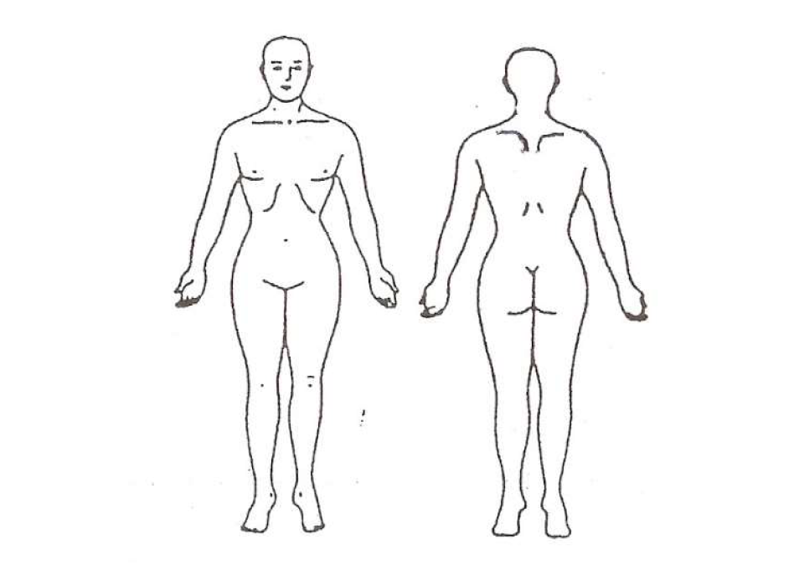

Diseases of the digestive organs:
Over acidity _____________________________________________________________
Appetite _____________________________________________________________
Stool regular irregular
shaped pulpy smelly
Constipation _____________________________________________________________
Wind _____________________________________________________________
Problems with Liver Gall bladder Hemorrhoids Others:
_______________________________________________________________________________
_______________________________________________________________________________
_______________________________________________________________________________

Gynecological / urological diseases
Menstruation disorders _____________________________________________________________
Painful menstruation ____________________________________________________________
Lengthy menstruation ____________________________________________________________
Strong bleedings during menstruation __________________________________________________
Sterility, unfulfilled child wish _________________________________________________________
Pain in breasts ____________________________________________________________
Kidneys ____________________________________________________________
Bladder ____________________________________________________________
Prostate ____________________________________________________________
Inflammations ____________________________________________________________
Stones ____________________________________________________________

Psychosocial environment
Do you feel stressed by people who are around you? (family members, neighbours, work colleagues,
etc.)
________________________________________________________________________________
________________________________________________________________________________
________________________________________________________________________________
________________________________________________________________________________

Date: _________________ Signed: ________________________________

